**Communication Class 7 (lesson 6)**

**All about the city:**

**Getting around**

**Teacher: Anastasiia Pushkar**

|  |  |
| --- | --- |
| **Imperative Structures** | |
| **When you tell people** *what****not****to do*, USE: | **When you tell people** *what to do*, USE: |
| **Don't V!** | **V!** |
| •**Don’t be** late! • **Don’t make** mistakes! • **Don’t tell** us what to do! :) | • **Be** nice! • **Do** your homework! • **Have** a good day! |
| **Don’t worry!** | **Be happy!** |

Functional language

**Task 1. Look at the pictures of different places around town; fill in the gaps with the words from the box.**

**[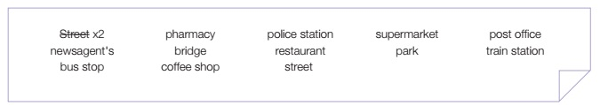](https://enbook.greenforest.ua/storage/uploads/2018/9/22/gaps.jpg)**

[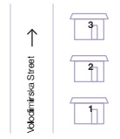](https://enbook.greenforest.ua/storage/uploads/2018/9/22/11.jpg)

|  |
| --- |
| Jack is walking up the *street.* |

[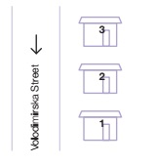](https://enbook.greenforest.ua/storage/uploads/2018/9/22/22.jpg)

|  |
| --- |
| Jack is walking down the |

[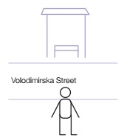](https://enbook.greenforest.ua/storage/uploads/2018/9/22/33.jpg)

|  |
| --- |
| There’s a  across the road |

[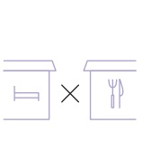](https://enbook.greenforest.ua/storage/uploads/2018/9/22/44.jpg)

|  |
| --- |
| There’s a  next to the hotel. |

[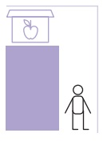](https://enbook.greenforest.ua/storage/uploads/2018/9/22/55.jpg)

|  |
| --- |
| The  is around the corner. |

[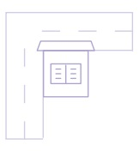](https://enbook.greenforest.ua/storage/uploads/2018/9/22/66.jpg)

|  |
| --- |
| The  is on the corner. |

[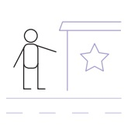](https://enbook.greenforest.ua/storage/uploads/2018/9/22/77.jpg)

|  |
| --- |
| There’s a  on the right. |

[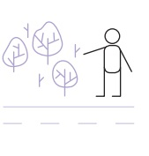](https://enbook.greenforest.ua/storage/uploads/2018/9/22/88.jpg)

[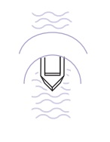](https://enbook.greenforest.ua/storage/uploads/2018/9/22/99.jpg)

|  |
| --- |
| There’s a boat under the  . |

[](https://enbook.greenforest.ua/storage/uploads/2018/9/22/10.jpg)

|  |
| --- |
| The bank is between a  and a bookshop. |

[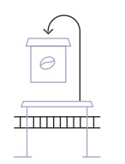](https://enbook.greenforest.ua/storage/uploads/2018/9/22/111.jpg)

|  |
| --- |
| There’s a  behind the  . |

|  |
| --- |
| There’s a  on the left. |

[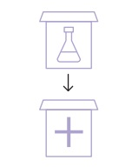](https://enbook.greenforest.ua/storage/uploads/2018/9/22/12.jpg)

|  |
| --- |
| The  is opposite the hospital. |

[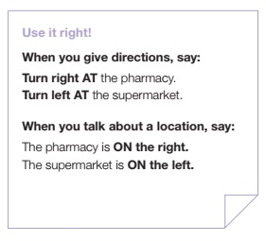](https://enbook.greenforest.ua/storage/uploads/2018/8/22/right.jpg)  
[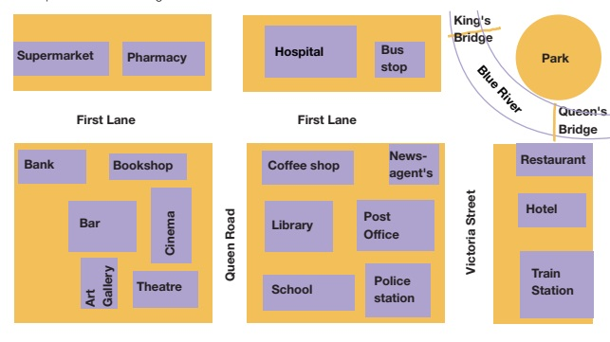](https://enbook.greenforest.ua/storage/uploads/2018/8/22/map.jpg)